|  |
| --- |
| Functional Specifications Document  Elite Event’s Planner  Project Code:    Project Advisor:  Miss Samreen Razzaq  Project Manager:  Dr. Hussam Ali  Project Team:  Hamza Abbas (MSIT62F21S038) Team Leader  Faisal Mustafa (MSIT62F21S028) Team Member  Haseeb Alam (MSIT62F21S050) Team Member  Submission Date:  23-March-2023 _____________________**Project Manager’s Signature** |

**Document Information**

| Category | Information |
| --- | --- |
| Customer | FAST-NU |
| Project | <Project Title> |
| Document | Functional Specifications |
| Document Version | 1.0 |
| Identifier | PGBH01-2003-FS |
| Status | Draft |
| Author(s) | <Names of all the authors of this document> |
| Approver(s) | PM |
| Issue Date | Sept. 15, 2003 |
| Document Location |  |
| Distribution | 1. Advisor 2. PM 3. Project Office |

**Definition of Terms, Acronyms and Abbreviations**

*This section should provide the definitions of all terms, acronyms, and abbreviations required to interpret the terms used in the document properly.*

| Term | Description |
| --- | --- |
| ASP | Active Server Pages |
| RS | Requirements Specifications |
|  |  |
|  |  |
|  |  |
|  |  |
|  |  |
|  |  |

**Table of Contents**

1. Introduction 4

1.1 Purpose of Document 4

1.2 Project Overview 4

1.3 Scope 4

2. Functional Requirements 4

3. Non-functional Requirements 4

3.1 Performance Requirements 4

3.2 Safety Requirements 4

3.3 Security Requirements 4

3.4 User Documentation 4

4. Assumptions and Dependencies 4

5. System Architecture 5

6. Use Cases 5

6.1 Use Case Diagrams 5

6.2 Use Case Description 5

7. Graphical User Interfaces 6

8. High Level Design 6

8.1 ER Diagram 6

8.2 Data Dictionary 6

*8.2.1 Data 1 6*

*8.2.2 Data 2 6*

*8.2.3 Data n 6*

9. Requirements Traceability Matrix 7

10. Risk Analysis 8

11. Cost Estimation Sheet 8

12. References 8

13. Appendices 9

# Introduction

* 1. Purpose of Document

The purpose of this document is to provide an overview of the Elite Event’s Planner project, its objectives, and its expected outcomes. It aims to communicate the project's scope, requirements, and deliverables to the stakeholders involved in the development and deployment of the study engine. Additionally, the document will provide a detailed description of the search engine's functionalities, including its architecture, algorithms, and user interface.

* 1. Project Overview

Now a days, everyone is so much busy in daily life’s routine. They have not much time for organizing their special events. So we are providing a platform where they could hire’s an event planner for organizing their events. An event planner is a professional who is specialize in this field and responsible for organizing and coordinating various types of events, such as weddings, corporate meetings, conferences, festivals, parties, ceremonies and other special occasions. Their main objective is to ensure that the event runs smoothly on time, and within budget, while also meeting the specific needs and expectations of the clients and attendees.

Events planners face a challenge in showcasing their skills, expertise, and past work in a centralized and effective manner. There is a need for a dedicated online platform that allows event planners to create detailed profiles featuring their portfolio, successful events, and client testimonials. Our website seeks to bridge this gap by providing event planners with a comprehensive platform to highlight their unique strengths and attract potential clients.

* 1. Scope

Our system can handle Wedding events, Cooperative events, Social events, catering services and decorating Services and accessories of both bridal and groom and providing many other services. Our system only organizing Pakistan Muslims events and not other minorities. And also we are not organizing political events.

In the previous days, there is no need of event planner because peoples are not organizing many events as compared to now a day. Now a days event planner became a formalized profession and the scope of events expanded. “Elite Project Planner” project could be used publicly. Any person which wants to organize any type of event, he can hire event planner anytime.

The scope of the event planners is quite broad, as events are a common occurrence in many industries and communities. Event planners can work with a variety of clients, including individuals, corporate clients, social clients, non-profit organizations, government agencies and educational institutions. The target market for event planners can vary depending on the type of event being planned, but generally includes individuals or organizations that require assistance in organizing and executing a successful event. This can include:

1. **Corporate clients:** These are businesses and organizations that need event planning services for conferences, product launches, trade shows, team building events, and other corporate events.
2. **Non-profit organizations:** These are charities, foundations, and other non-profit organizations that require event planning services for fundraisers, galas, charity auctions, and other events to raise awareness and funds*.*
3. **Social clients:** These are individuals who require event planning services for personal events such as weddings, birthdays, anniversary parties, baby showers, and other special occasions.
4. **Government agencies:** These are public sector organizations that require event planning services for public events, such as inaugurations, official openings, and other public events.
5. **Educational institutions:** These are schools, universities, and other educational institutions that require event planning services for graduation ceremonies, conferences, workshops, and other events.

# Functional Requirements

1. Users can login and register.
2. User can share their experiences with others and can view their experience at the website.
3. Users should be able to check portfolio, view profiles of service providers team members, and then hire the team of Elite Event’s Planner according to their requirements.
4. Users should be able to view one by one all categories of a website like user can check list of services,
5. Users should be able to view list of corporate events like corporate dinners, award ceremonies, conferences, meetings, seminars etc. and can view the list of social events like birthdays, farewell parties, religious ceremonies, wedding anniversary and also cultural events etc. and wedding event.
6. Users in the end will fill the form for hiring event planner team and tell the requirements in a form which they need. He will select name, email, phone no, events, estimated budgets, dates and can add additional notes.
7. User can join us by filling the form in which he can enter name, phone no, qualification, skills, email and he can add the cv
8. User can view the list of accessories and our sponsored brands.
9. User can list of blogs of different types of events.
10. User can check the gallery for viewing different types of events images.
11. Admin can login with admin account for getting access of all databases and settings.
12. Admin should be able to view and manage all events on the platform, including event creation, modification, and deletion.
13. Admin should be able to manage different types of events. In the list of event he can add new, update already exist and delete events according to time.
14. Admin should be able to manage services. He can add new, update already exist and delete services.
15. Admin should be able to manage accessories. He can add new, update already exist and delete services.
16. Admin can check list of bookings.

# Non-functional Requirements

* 1. Performance Requirements

1. **Speed:** The system should respond quickly to user requests, particularly during peak periods, to ensure that event planning activities are not delayed.
2. **Precision:** The system should provide accurate information about event planning details such as location, dates, time, attendees, etc., to ensure that events are well-organized and executed as planned.
3. **Capacity:** The system should have enough capacity to handle multiple events simultaneously, particularly during peak periods, to avoid downtime or system crashes.
4. **Safety:** The system should ensure the security and confidentiality of sensitive information such as payment details, event plans, attendees’ personal information, etc.
5. **Reliability:** The system should be reliable, available, and accessible to users at all times to avoid disruptions to event planning activities.
   1. Safety Requirements
6. **Compliance with Safety Regulations:** Our event planner system must comply with all relevant safety regulations and policies, such as fire codes, building codes, and health and safety regulations.
7. **Safe Venue Selection:** Our system should have a feature that enables event planners to select a venue that meets safety standards, such as the availability of emergency exits, fire suppression systems, and adequate lighting.
8. **Risk Assessment and Mitigation:** Our system should conduct a risk assessment of the event and identify potential hazards such as fire, overcrowding, and physical obstructions. The system should also have measures in place to mitigate these risks, such as providing adequate staff and equipment.
9. **Emergency Planning:** Our system should have an emergency plan in place for each event, including procedures for evacuating the venue, contacting emergency services, and providing medical assistance.
10. **Safety Training:** Our system should provide training materials for event staff and attendees to educate them on safety procedures and measures.
11. **Safety Certifications:** Our system should obtain relevant safety certifications, such as a fire safety certificate or a health and safety certificate.
12. **Incident Reporting and Investigation:** Our system should have a mechanism for reporting and investigating incidents related to safety, such as accidents or injuries.

By incorporating these non-functional requirements, the event planner project can ensure the safety of all attendees and staff and comply with relevant safety regulations and policies.

* 1. Security Requirements

Here are some non-functional security requirements for an event planner project:

1. **Authentication and Authorization:** Our system must implement robust user authentication and authorization mechanisms to prevent unauthorized access to the system. It must allow only authorized users to access the system and perform specific actions based on their roles and privileges.
2. **Data Protection:** Our system must ensure the confidentiality and integrity of all data used or created by the system. It must provide secure data storage, access control mechanisms, and encryption techniques to protect against unauthorized access, modification, or disclosure.
3. **Security Policies**: Our system must comply with all relevant security policies and regulations, including but not limited to, data protection, privacy, and information security standards. It must also adhere to any specific security or privacy policies or certifications required by the organization or industry.
4. **Physical Security:** Our system must ensure physical security measures are in place to protect against unauthorized access to the servers or other hardware components that store or process data. It must also provide secure access control mechanisms, like biometric or RFID-based authentication, to prevent physical access to sensitive areas.
5. **Security Training:** Our system must provide security training and awareness to all system users to ensure they understand the security policies, procedures, and best practices. It must also periodically assess the security knowledge and skills of the users and provide additional training as needed.
   1. User Documentation

User documentation components that should be delivered along with the software are:

1. **User manuals:** These should provide detailed instructions on how to use the software, including screenshots and step-by-step guides.
2. **Online help:** This should provide users with quick access to information about the software, including FAQs, troubleshooting tips, and best practices.
3. **Tutorials:** These should provide users with a more interactive and engaging way to learn about the software, through videos and other multimedia content.
4. **Technical documentation:** This should provide developers and IT staff with detailed information about the software's architecture, APIs, and other technical aspects.
5. **Release notes:** These should provide users with information about new features and bug fixes that are included in each software release.

# Assumptions and Dependencies

**Assumptions:**

1. There is a market demand for event planning services, and people are willing to pay for such services.
2. The event planning industry is competitive, with many players offering similar services.
3. The company has access to a pool of talented and experienced event planners who are willing to work on a freelance or contract basis.
4. The company has access to the necessary technology and software to manage and coordinate events effectively.
5. The company has a good reputation in the market, and clients trust them to deliver high-quality event planning services.

**Dependencies:**

1. Availability of skilled and experienced event planners who are willing to work on a freelance or contract basis.
2. Availability of reliable vendors who can provide services such as catering, audio-visual equipment, and transportation etc.
3. Availability of suitable venues that can accommodate the client's requirements.
4. Availability of necessary permits and licenses to hold events in specific locations.
5. Access to sufficient funding to cover expenses such as salaries, equipment, and marketing costs.
6. Dependency on a banking system for online payment transaction.

# System Architecture

The architecture of our project is three-tiered. The application layer, business layer, and data layer are the three layers that make up the three-tier architecture. Furthermore, each layer is handled as a distinct module, which includes independent development and maintenance. The Presentation layer is the entry point to the three-tier architecture. This part is often the part that is seen by the customer and therefore it is often referred to as a graphic user interface or GUI. The frontend and backend components make up the presentation layer. IN our system we will use PhP on frontend and Bootstrap in backend. The business layer is also often called a service layer. This layer uses business logic and business rules to save and process data. The data layer is the final layer that is used to process final data requests. The data obtained in the business layer in our system is stored in SQL database.

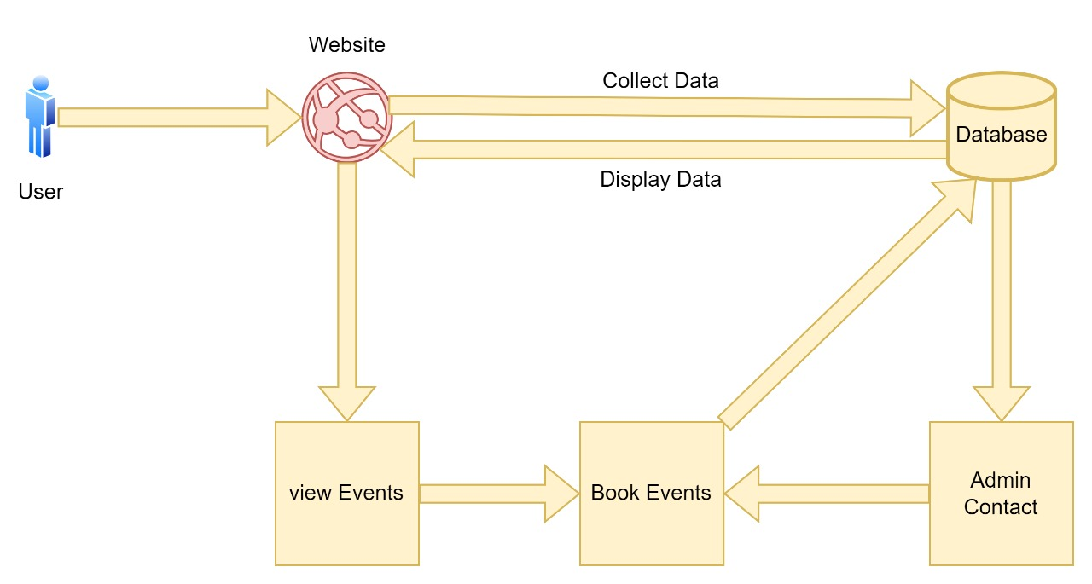

Figure 1: system Architecture

# Use Cases

* 1. Use Case Diagrams

In this section provide use case diagrams using UML convention.

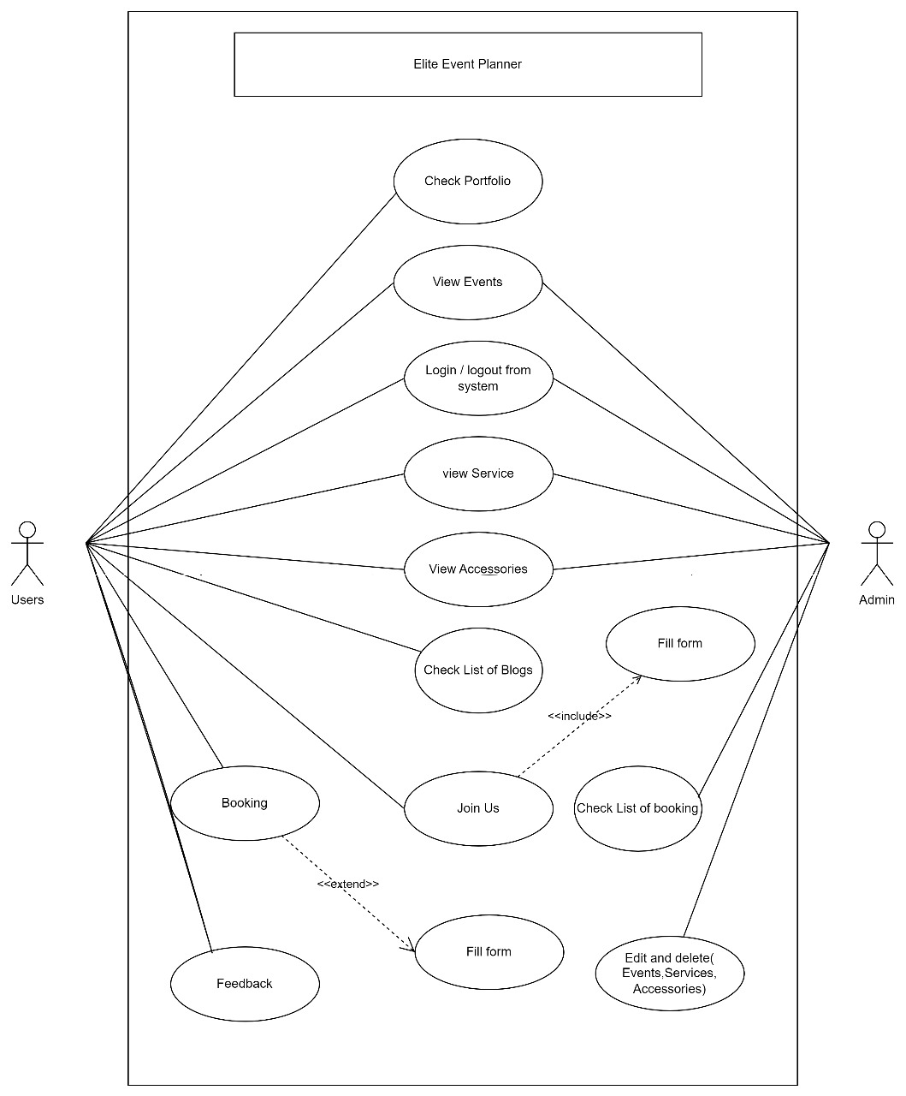

Figure 2: Use Case

* 1. Use Case Description

The customer first opens the website of elite event’s planner. He will open the sign up first. The sign-up form showed him. The customer will enter the required information for filling in the form. He will submit the form, then return or confirmation message shown to him for successful sign-up form of the customer*.*

|  |  |  |  |  |
| --- | --- | --- | --- | --- |
| **UC-01: Sign-in/Login** | | | | |
| **Actors:**  Primary actor: Visitor, Secondary actor: Admin | | | | |
| **Feature:**  *<Feature from which the use case is driven>* | | | | |
| **Use case Id:** | | *UC-01* | | |
| **Pre-condition:** | | 1. Person who wants to get over services need to have an  active internet*.*  *2.* Login page should not be accessible by everyone | | |
| **Scenarios** | | | | |
| **Step#** | **Action** | | | **Software Reaction** |
| **1.** | Visitor will open the sign-up page | | | The sign-up form showed him |
| **2.** | And then fill in their name and requirements then to get over services | | | Successfully to fill all the requirements |
| **3.** | He will submit the form | | | Then return or confirmation message is shown to him for successful sign-up form of the visitor. |
| **Alternate Scenarios:** If the visitor credentials are incorrect, the system presents an error message and returns to the login screen. | | | | |
| **1a:**  **2a:** | | | | |
| **Post Conditions:** The system is updated and running the latest version. | | | | |
| **Step#** | **Description** | | | |
|  | The administrator logs in to the system. | | | |
|  | The system verifies the administrator's credentials. | | | |
|  | The system presents the administrator with two options: system reporting and system update. | | | |
|  | The administrator selects the system reporting option. | | | |
|  | The system generates a report on the system's health status and presents it to the administrator. | | | |
|  | The administrator reviews the report. | | | |
|  | The administrator selects the system update option. | | | |
|  | The system checks for available updates. | | | |
|  | If updates are available, the system prompts the administrator to confirm the update. | | | |
|  | The administrator confirms the update. | | | |
|  | The system downloads and installs the update | | | |
|  | The system restarts to complete the update process. | | | |
|  | The system presents a message confirming the update process has completed successfully | | | |
| **Use Case Cross referenced** | | |  | |
| **User Interface reference** | | | The system presents the administrator with a menu containing the options for login form, | |
| **Concurrency and Response**   * Only one administrator can perform system maintenance at a time. * The system generates a report on the system's health status and presents it to the administrator. If updates are available, the system prompts the administrator to confirm the update. The system presents a message confirming the update process has completed successfully | | | | |

|  |  |  |  |  |
| --- | --- | --- | --- | --- |
| **UC-02: View Event** | | | | |
| **Actors:**  Primary actor: Visitor, Secondary actor: Admin | | | | |
| **Feature:**  *<Feature from which the use case is driven>* | | | | |
| **Use case Id:** | | *UC-02* | | |
| **Pre-condition:** | | System application events should be available for the customer to hire the event planner. | | |
| **Scenarios:** The visitor view all events | | | | |
| **Step#** | **Action** | | | **Software Reaction** |
| **1.** | When the customer want to view the types of events then click on the tab of event and select type of event and click on it. | | | The system shows particular events types. |
| **Alternate Scenarios:** user can select wrong type of events page | | | | |
| **1a:**  **2a:** | | | | |
| **Post Conditions:** The customer view events successfully | | | | |
| **Step#** | **Description** | | | |
| **1.** | The visitor views all event without login the website. | | | |
| **2.** | Then visitor view all event then click on book now. | | | |
| **3.** | The visitor successfully view all event | | | |
| **Use Case Cross referenced** | | | *UC-01,UC-03,UC-04* | |
| **User Interface reference** | | | The website presents the visitor to provide the functionality to view the event. | |
| **Concurrency and Response**   * *Visitors view all event and click on book now button.* | | | | |
|  | | | | |

|  |  |  |  |  |
| --- | --- | --- | --- | --- |
| **UC-03: View Services** | | | | |
| **Actors:**  Primary actor: Visitor, Secondary actor: Admin | | | | |
| **Feature:**  *<Feature from which the use case is driven>* | | | | |
| **Use case Id:** | | *UC-03* | | |
| **Pre-condition:** | | Person who want to find list of service go on the service page of website. | | |
| **Scenarios:** The visitor check the list of services. | | | | |
| **Step#** | **Action** | | | **Software Reaction** |
| **1.** | When the customer want to check list of services he will go service tap and click on it. The system will show all the services | | | The system shows all the items. |
| **Alternate Scenarios:**  User can select wrong type of services page . | | | | |
| **1a:**  **2a:** | | | | |
| **Post Conditions:** The customer view services successfully | | | | |
| **Step#** | **Description** | | | |
| **1.** | The visitor views all services without login the website. | | | |
| **2.** | Then visitor view all event then click on hire us button . | | | |
| **3.** | The visitor successfully view all services | | | |
| **Use Case Cross referenced** | | | *UC-01,UC-02,UC-03* | |
| **User Interface reference** | | | The website presents the visitor to provide the functionality to view the services. | |
| **Concurrency and Response**   * *Visitors view all services and then click on button on hire you.* | | | | |
|  | | | | |

|  |  |  |  |  |
| --- | --- | --- | --- | --- |
| **UC-04: View Accessories** | | | | |
| **Actors:**  Primary actor: Visitor, Secondary actor: Admin | | | | |
| **Feature:**  *<Feature from which the use case is driven>* | | | | |
| **Use case Id:** | | *UC-04* | | |
| **Pre-condition:** | | Person who want to find list of se go on the accessories page of website. | | |
| **Scenarios:** The visitor check the list of accessories. | | | | |
| **Step#** | **Action** | | | **Software Reaction** |
| **1.** | When the customer want to check list of accessories he will go accessories tab and click on it. | | | The system shows all the items. |
| **Alternate Scenarios:**  User can select wrong type of accessories page . | | | | |
| **1a:**  **2a:** | | | | |
| **Post Conditions:** The customer view accessories successfully | | | | |
| **Step#** | **Description** | | | |
| **1.** | The visitor views all accessories without login the website. | | | |
| **2.** | The visitor successfully view all accessories. | | | |
| **Use Case Cross referenced** | | | *UC-01,UC-02* | |
| **User Interface reference** | | | The website presents the visitor to provide the functionality to view the accessories . | |
| **Concurrency and Response**   * *Visitors view all accessories.* | | | | |
|  | | | | |

|  |  |  |  |  |
| --- | --- | --- | --- | --- |
| **UC-05: View List of Blogs** | | | | |
| **Actors:**  Primary actor: Visitor, Secondary actor: Admin | | | | |
| **Feature:**  *<Feature from which the use case is driven>* | | | | |
| **Use case Id:** | | *UC-05* | | |
| **Pre-condition:** | | Person who want to find list of se go on the blogs page of website. | | |
| **Scenarios:** The visitor check the list of  . | | | | |
| **Step#** | **Action** | | | **Software Reaction** |
| **1.** | When the customer want to check list of blogs he will go blog tab and click on it. The system will show all the list of blogs . | | | The system shows all the blogs list. |
| **Alternate Scenarios:**  User can select wrong blogs page. | | | | |
| **1a:**  **2a:** | | | | |
| **Post Conditions:** The customer view list of blogs successfully | | | | |
| **Step#** | **Description** | | | |
| **1.** | The visitor views all list of blogs without login the website. | | | |
| **2.** | When visitor view list of blogs, then click on selected blog page and move on that . | | | |
| **3.** | The visitor successfully view all list of blogs. | | | |
| **Use Case Cross referenced** | | | *UC-01,UC-02* | |
| **User Interface reference** | | | The website presents the visitor to provide the functionality to view the list of blogs. | |
| **Concurrency and Response**   * *Visitors view all list of blogs.* | | | | |
|  | | | | |

|  |  |  |  |  |
| --- | --- | --- | --- | --- |
| **UC-06: Check Portfolio** | | | | |
| **Actors:**  Primary actor: Visitor, Secondary actor: Admin | | | | |
| **Feature:**  *<Feature from which the use case is driven>* | | | | |
| **Use case Id:** | | *UC-06* | | |
| **Pre-condition:** | | Person who want to check portfolio of team member, go on the portfolio page of website. | | |
| **Scenarios:** The visitor check the list of team members.  . | | | | |
| **Step#** | **Action** | | | **Software Reaction** |
| **1.** | When the customer want to check portfolio, he will go about us Tab and select our-staff tab. | | | The system shows portfolio page. |
| **Alternate Scenarios:**  User can select wrong blogs page. | | | | |
| **1a:**  **2a:** | | | | |
| **Post Conditions:** The customer view portfolio successfully | | | | |
| **Step#** | **Description** | | | |
| **1.** | The visitor views portfolio without login the website. | | | |
| **2.** | When visitor view portfolio page, then go on the specific profile and it will hover into his Facebook, Twitter and Instagram profile. | | | |
| **3.** | The visitor successfully view portfolio page. | | | |
| **Use Case Cross referenced** | | | *UC-01,UC-02* | |
| **User Interface reference** | | | The website presents the visitor to provide the functionality to view the portfolio. | |
| **Concurrency and Response**   * *Visitors view portfolio.* | | | | |
|  | | | | |

# Graphical User Interfaces

Give a detailed account of user interfaces included in this project.

|  |  |  |
| --- | --- | --- |
| **User Interface 01: Landing Page** | | |
| **Interface Id.** | | *Write the reference number assigned to this UI.* |
| **Use case Reference** | | *Refer to the use case invoking this UI.* |
| **Snapshot** | | |
|  | | |
| **Data dictionary reference** | | |
| **Label** | **Data dictionary identifier** | |
|  | *Refer to fields in data dictionary* | |
|  |  | |
|  |  | |
|  |  | |

|  |  |  |
| --- | --- | --- |
| **User Interface 02: Registration Page** | | |
| **Interface Id.** | | *Write the reference number assigned to this UI.* |
| **Use case Reference** | | *Refer to the use case invoking this UI.* |
| **Snapshot** | | |
|  | | |
| **Data dictionary reference** | | |
| **Label** | **Data dictionary identifier** | |
|  | *Refer to fields in data dictionary* | |
|  |  | |

|  |  |  |
| --- | --- | --- |
| **User Interface 03: Login Page** | | |
| **Interface Id.** | | *Write the reference number assigned to this UI.* |
| **Use case Reference** | | *Refer to the use case invoking this UI.* |
| **Snapshot** | | |
|  | | |
| **Data dictionary reference** | | |
| **Label** | **Data dictionary identifier** | |
|  | *Refer to fields in data dictionary* | |
|  |  | |
|  |  | |
|  |  | |

|  |  |  |
| --- | --- | --- |
| **User Interface 04: Blogs Page** | | |
| **Interface Id.** | | *Write the reference number assigned to this UI.* |
| **Use case Reference** | | *Refer to the use case invoking this UI.* |
| **Snapshot** | | |
|  | | |
| **Data dictionary reference** | | |
| **Label** | **Data dictionary identifier** | |
|  | *Refer to fields in data dictionary* | |
|  |  | |
|  |  | |
|  |  | |

|  |  |  |
| --- | --- | --- |
| **User Interface 05: Events Page** | | |
| **Interface Id.** | | *Write the reference number assigned to this UI.* |
| **Use case Reference** | | *Refer to the use case invoking this UI.* |
| **Snapshot** | | |
|  | | |
| **Data dictionary reference** | | |
| **Label** | **Data dictionary identifier** | |
|  | *Refer to fields in data dictionary* | |
|  |  | |
|  |  | |
|  |  | |

|  |  |  |
| --- | --- | --- |
| **User Interface 06: Services Page** | | |
| **Interface Id.** | | *Write the reference number assigned to this UI.* |
| **Use case Reference** | | *Refer to the use case invoking this UI.* |
| **Snapshot** | | |
|  | | |
| **Data dictionary reference** | | |
| **Label** | **Data dictionary identifier** | |
|  | *Refer to fields in data dictionary* | |
|  |  | |
|  |  | |
|  |  | |

|  |  |  |
| --- | --- | --- |
| **User Interface 07: Accessories Page** | | |
| **Interface Id.** | | *Write the reference number assigned to this UI.* |
| **Use case Reference** | | *Refer to the use case invoking this UI.* |
| **Snapshot** | | |
|  | | |
| **Data dictionary reference** | | |
| **Label** | **Data dictionary identifier** | |
|  | *Refer to fields in data dictionary* | |
|  |  | |
|  |  | |
|  |  | |

|  |  |  |
| --- | --- | --- |
| **User Interface 08: Our-Staff Page** | | |
| **Interface Id.** | | *Write the reference number assigned to this UI.* |
| **Use case Reference** | | *Refer to the use case invoking this UI.* |
| **Snapshot** | | |
|  | | |
| **Data dictionary reference** | | |
| **Label** | **Data dictionary identifier** | |
|  | *Refer to fields in data dictionary* | |
|  |  | |
|  |  | |
|  |  | |

# High Level Design

* 1. ER Diagram

The enhanced entity-relationship EER diagram is used to represent an entity relationship in a system. It define different types relationship of entity with one another

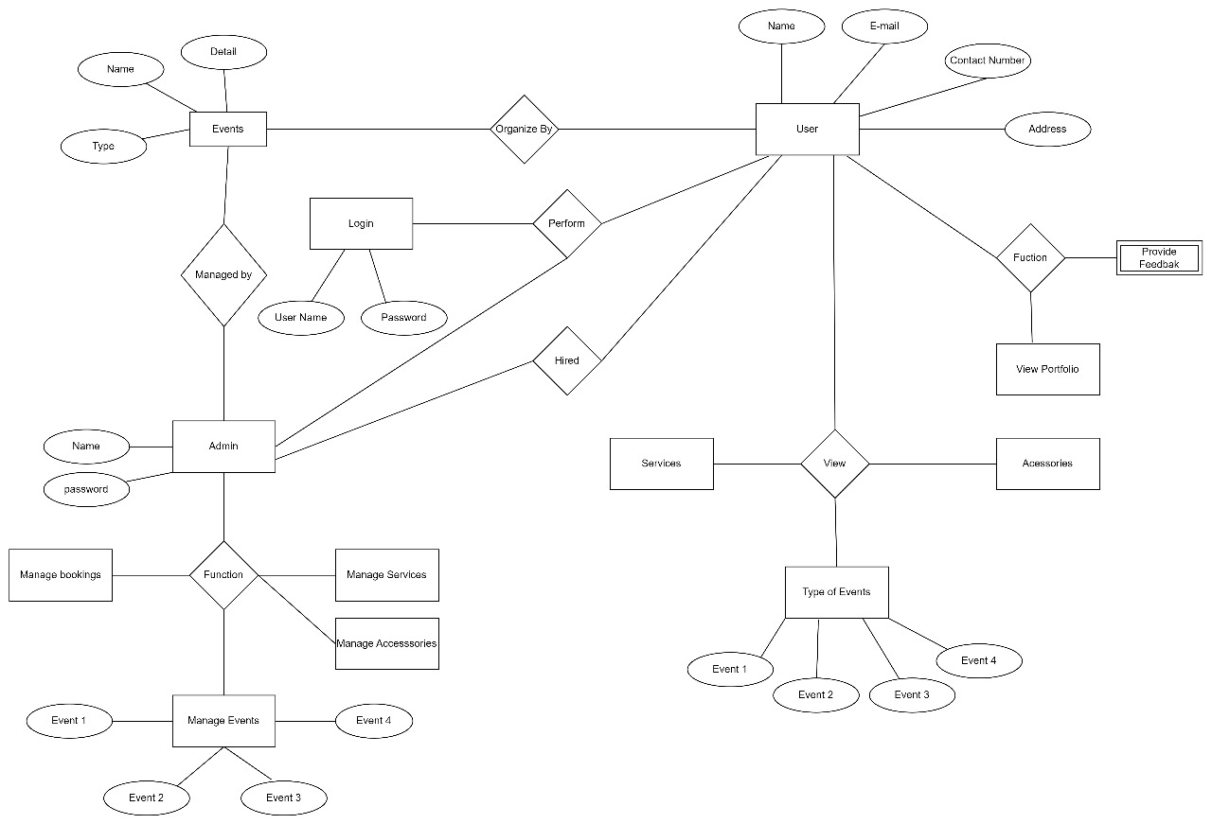

# Requirements Traceability Matrix

|  |  |  |  |  |  |  |
| --- | --- | --- | --- | --- | --- | --- |
| **Sr. #** | **Feature** | **Use case ID** | **UI ID** | **Priority** | **Build Number** | **Use Case Cross reference**  **(Related Use Cases)** |
| 1 | Events | UC2 | UI5 | High | 1.0 | UC1,UC3,UC4 |
| 2 | Services | UC3 | UI6 | High | 2.0 | UC1,UC2,UC3 |
| 3 | Accessories | UC4 | UI7 | High | 2.0 | UC1,UC2 |
| 4 | Blogs | UC5 | UI4 | High | 3.0 | UC1,UC2 |
| 5 | Check portfolio | UC6 | U18 | High | 4.0 | UC1,UC2 |

*The columns carry the following meaning:*

* *Feature: Lists system features based on which use cases are built.*
* *Use Case ID: Write the ID of the use case for easy lookup*
* *UI ID: Write the user interface ID for this use case.*
* *Priority: Give an appropriate rating to each use case according to its priority*
* *Build Number: Write the reference number to which this feature belongs.*
* *Use Case Cross Ref: Write the related use cases separated with commas.*

# Risk Analysis

Risk analysis is a crucial step in any project development, as it helps to identify potential risks that could

adversely affect the project. The following is a risk analysis for the SRS of this project:

* 1. **Risk Identification**

**Data breach:** Some common types of risk that may be occur are theft, discrimination etc. we need to find out what has happened in our situation and decide if it was the result of human error, a system error or something else.

**Data loss:** The biggest reasons for data loss include laptop theft, accidental deletion or overwriting of files, power outages and or sudden failure of hard drives.

**Device damaged:** The device may be damaged which contain all data related to project

**Personnel changes:** If a key team member leaves the project, it could result in a delay in the project timeline or

a loss of valuable knowledge and expertise.

**Model accuracy:** The model's accuracy may not be up to the mark as it depends on various factors such as the

quality of images captured, environmental factors, etc.

* 1. **Risk drivers**

1. Insufficient security measures and protocols.

2. Physical damage or theft of laptop.

3. Limited knowledge and skills of the development team

4. Lack of backup and recovery mechanisms..

5.inadequate designing data for website navigation

**10.3 Percentage impact of Risk Drivers**

1. Insufficient security measures and protocols: 35%

2.Lack of backup and recovery mechanisms:25%

3. Limited knowledge and skills of the development team:15%

4. Physical damage or theft of laptop:15%

5.inadequate designing data for website navigation:10%

**10.4 Risk Mitigation plan**

**Data breach:** Appropriate security measures, such as encryption and secure data transmission protocols,

must be implemented.

**Data loss:** Regular backup and recovery mechanisms should be in place, and data should be stored on cloud

servers to prevent data loss due to physical device damage.

**Device damaged:** Data should be synced regularly with cloud servers to prevent data loss due to physical damage

or theft of laptop.

**Personnel changes:** A clear knowledge transfer plan should be in place, and team members should be cross

trained to mitigate the risk of a single point of failure.

**Model accuracy:** The development team should continuously monitor and improve the accuracy of the model

through regular updates and improvements in the designing.

# Cost Estimation Sheet

**(Consult** **your Project Manager for this section)**

|  |  |  |
| --- | --- | --- |
|  | **Software development cost** | 10,000 |
|  | **Packaged software** | 500 |
|  | **Hardware** | 5,000 |
|  | **Network** | 2,500 |
|  | **Client** | 3,000 |
|  | **Misc.** |  |
|  |  |  |
|  |  | **Total cost =56,000** |

# References

*This section should provide a complete list of all documents referenced at specific point in time. Each document should be identified by title, report number (if applicable), date, and publishing organization. Specify the sources from which the references can be obtained (This section is like the bibliography in a published book).*

|  |  |
| --- | --- |
| [1] | M. Manager, E. Smith and K. Jones, Wedding Planner Group, istanbul,dubai,london,delhi, 2022. |
| [2] | A. Almass and A. sattr, Shadi Welcome, Lahore, 2017. |
| [3] | M. Ali and M. Aslam, Eventoxs Event Management, Islambad, 2021. |
| [4] | M. Waqar, M. Areeb and A. Amna, FIND AN EVENT MANAGEMENT COMPANY, Islamabad,Lahore, 2020. |
| [5] | K. Shahzad, R. Faisal and H. Mazhar, Innovative Events Expert, Islamabad,Lahore,Multan,Gujranwala, 2019. |

# Appendices

*Include supporting details that would be too distracting to include in the main body of the document.*